**COP 4424 NETAŞ ADVANCED WEB TECHNOLOGIES**

**1.Motivation and Introduction**

From the begining of my childhood I was always in to animations and cartoons and I always wanted to inspire and suggest animations and cartoons to other people thats why I tried to make a website that suggests Japanese Animations which are called ”Anime’s” and allowing each user to add the suggestions that they liked to their Favorites list.

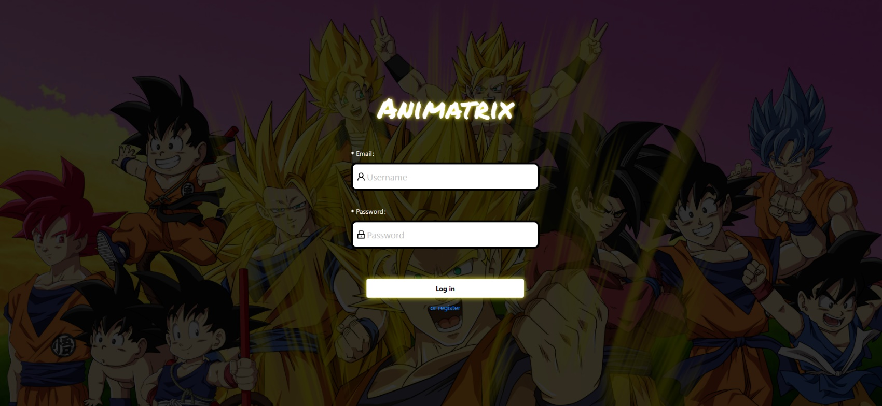**2.LITERATURE REVIE**

**When an User first enters the site Called Animatrix he/she will be redircted to the Login page and then he will asked to enter his/her email and password or if they dont have those there wil be a register button under the login page as shown in the Picture**

**The button,the login form, and texts, and**

**register link are from [1]antDesign**

**The Font family belongs to [2]googleFonts**

**You can register with FirstName,LastName,Email and password 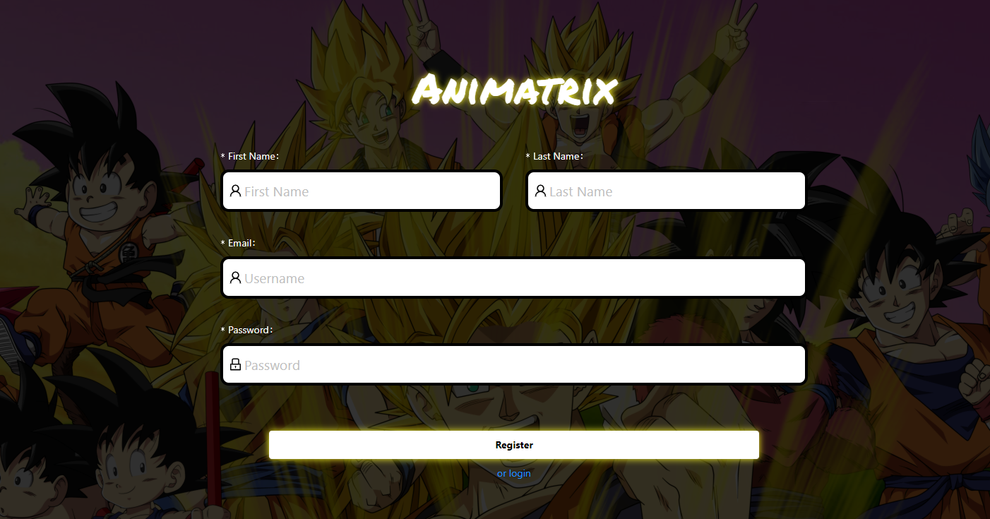you must enter all of them in order to register.**

**The form,button,Login page Link are from [1]antDesign**

**Font family is from [2]**googleFonts

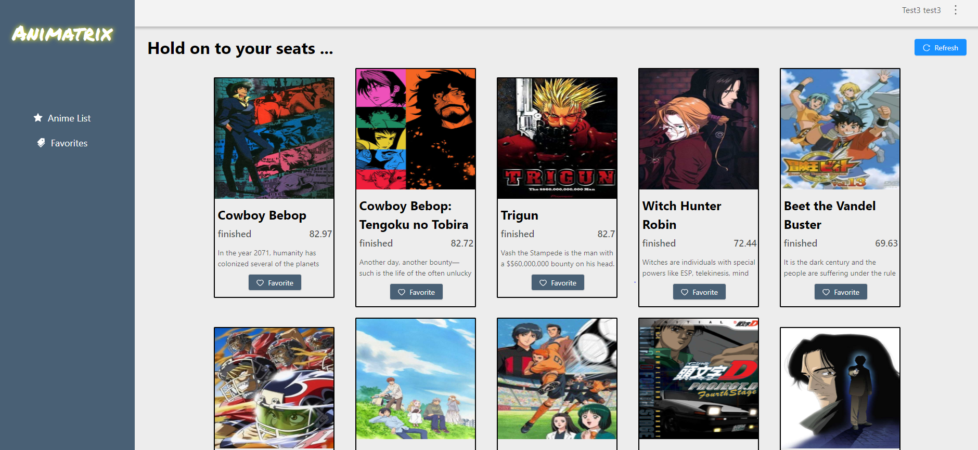

**You can view the animations in here and if you dont like anything you can lick the refresh button to get a new set of them**

**And your FullName is on the top right side so you can see you logged in correctly**

**Button,header,sider is from [1]antDesign**

**REFERENCES**

**React – A JavaScript library for building user interfaces In-text: [3]**

**[3]"React – A JavaScript library for building user interfaces", Reactjs.org. [Online]. Available: https://reactjs.org/. [Accessed: 01- Dec- 2019].**

**MongoDB**

**In-text: [4]**

**[4]"The most popular database for modern apps", MongoDB. [Online].**

**Available:** [**https://www.mongodb.com**](https://www.mongodb.com)**/.**

**Mongoose ODM v5.7.13**

**In-text: [5]**

**[5]Mongoose ODM v5.7.13", Mongoosejs.com. [Online]. Available:** [**https://mongoosejs.com/**](https://mongoosejs.com/)**.**

**[1]Ant Design - A UI Design Language and React UI library. [online] Available at: https://ant.design/ [Accessed 1 Dec. 2019].**

**[2] Google Fonts. [online] Available at: https://fonts.google.com/ [Accessed 1 Dec. 2019].**